**PROJECT REPORT**

**Title :**

**Crafting MyFlix: A Streaming Platform with HTML, CSS, and JavaScript.**

**Date:** 03-03-2024

**Student:**

Name: Prathmesh Pradip Patil

Branch: Computer technology

Sec:B

Roll NO:138

Enroll no.: 22070424

**Faculties:**

Prof. A.K.Kadu

Prof. S.S.Sahare

**Collage: Yashwantrao Chavan Collage of Engineering,Nagpur.**

**Introduction :**

The 'MyFlix' project is a streaming platform developed using HTML, CSS, and JavaScript, designed to offer users an engaging entertainment experience. The home page, crafted with HTML and CSS, resembles the familiar user interface of Netflix and provides users with information about the platform's features, special offers, and content. By clicking the 'Get Started' button, users are seamlessly directed to the login page, implemented with JavaScript. After successful login authentication, users navigate to the subscription page, where they can select from various packages crafted using HTML and styled with CSS. Following subscription selection, users proceed to the payment page, where JavaScript facilitates payment processing. Once payment is successful, users gain access to the main streaming page, where HTML and JavaScript combine to deliver a diverse selection of videos.

**Summary:**

The 'My Flix' streaming platform, developed with HTML, CSS, and JavaScript, offers users a seamless experience from login to streaming. HTML and CSS create a visually appealing home page, reminiscent of Netflix, while JavaScript facilitates user interaction, guiding users through the login process and subscription selection. HTML structures and CSS styles the subscription page, providing users with various package options. JavaScript enables payment processing on the payment page, ensuring a smooth transaction experience. Once payment is complete, HTML and JavaScript combine to present users with a rich selection of streaming content on the main streaming page

**Program code :**

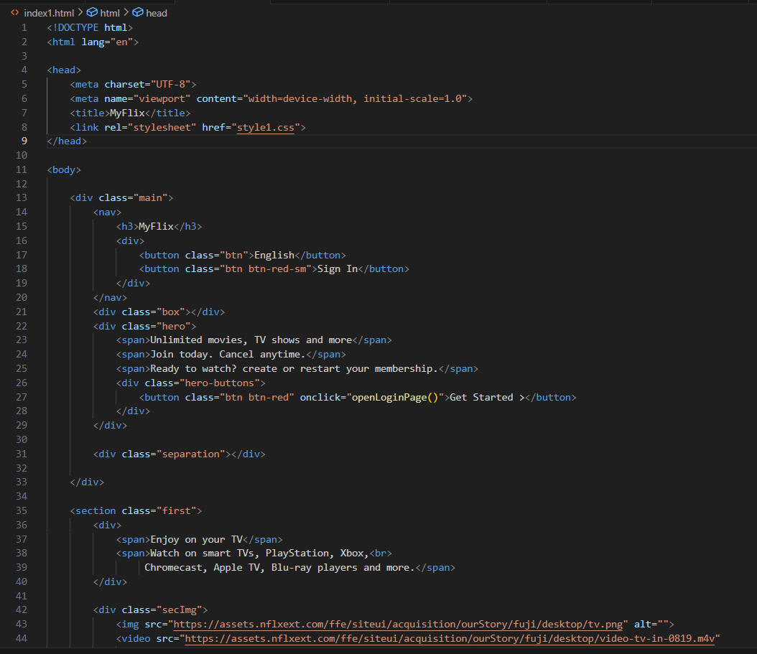

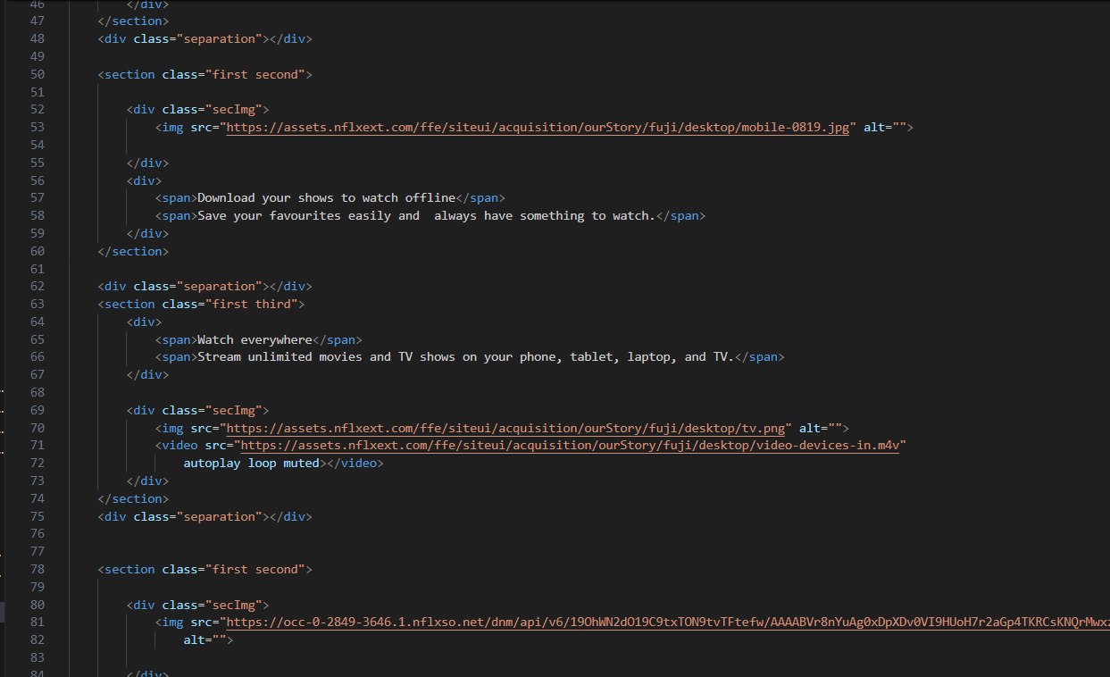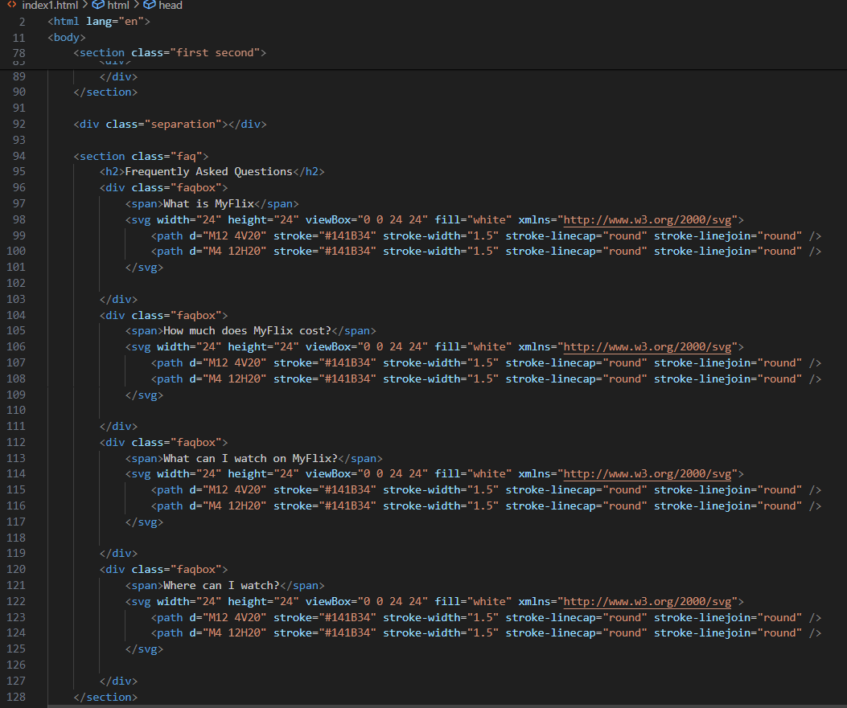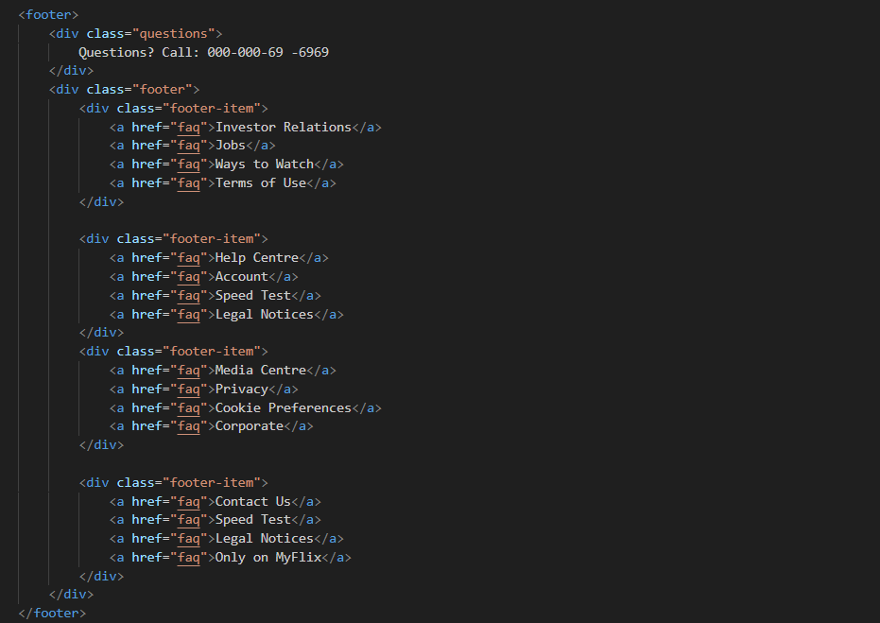

Style.css

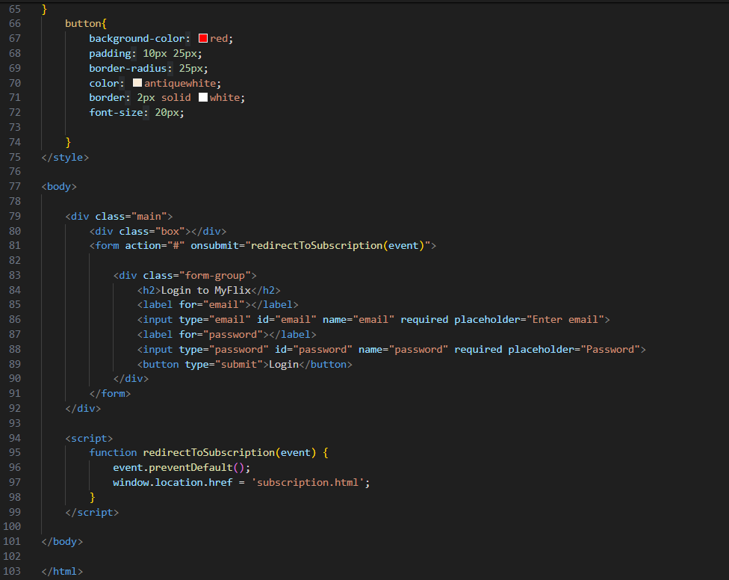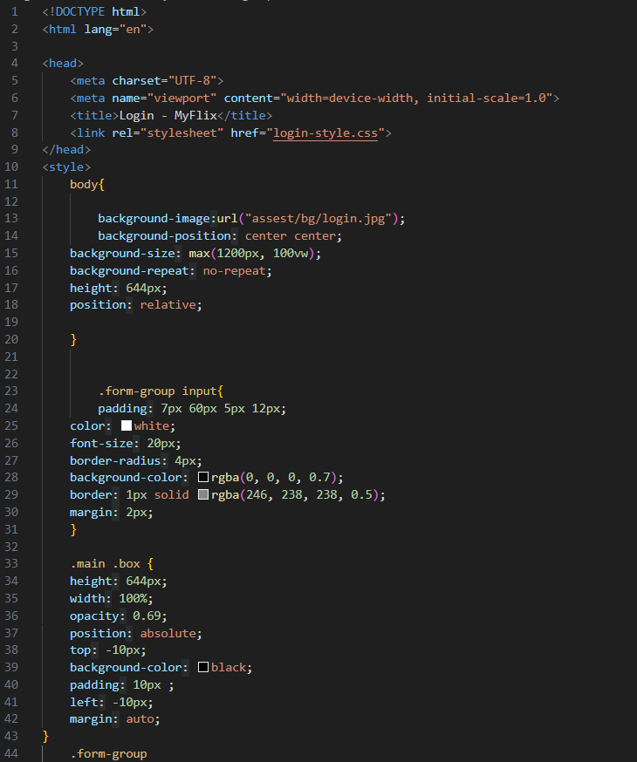

OUTPUT:

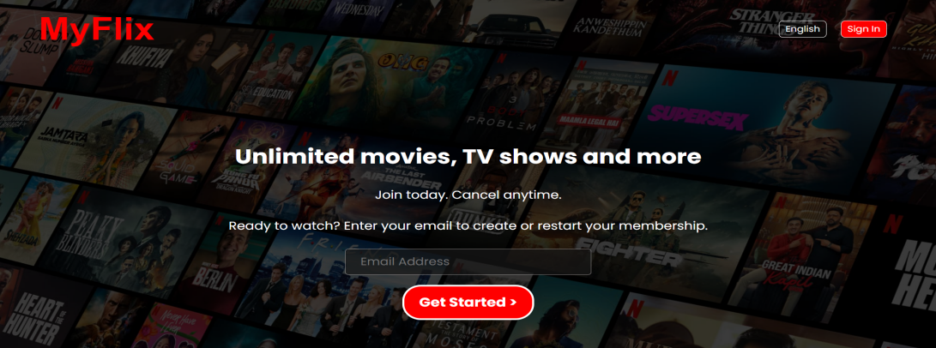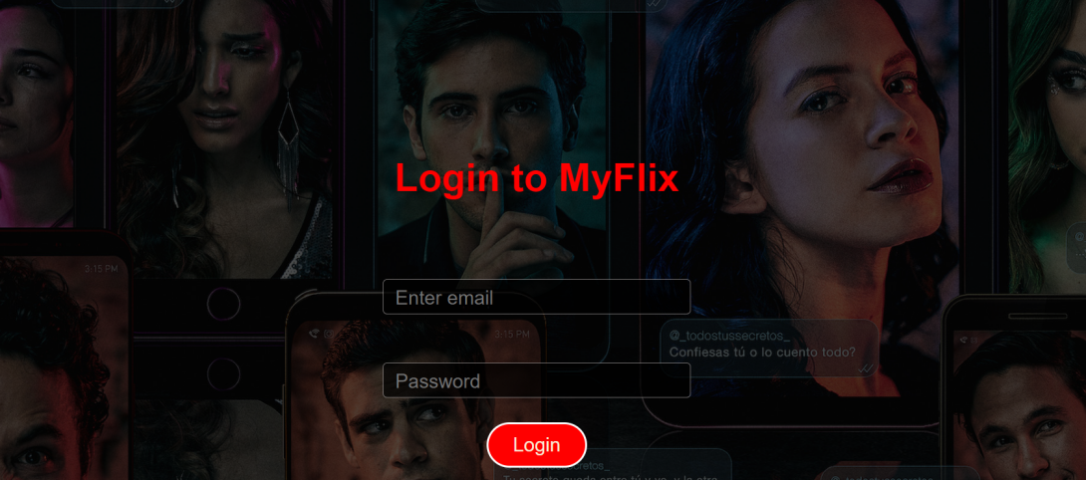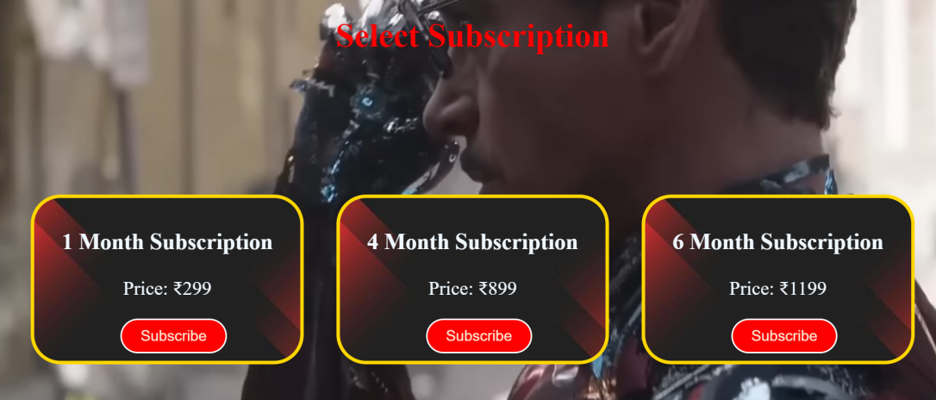

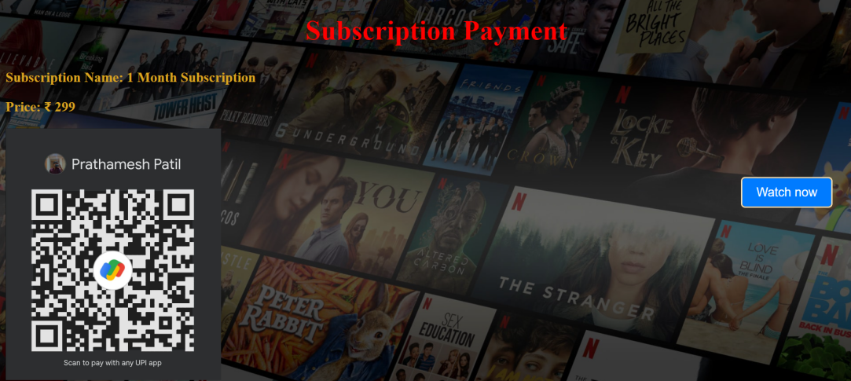

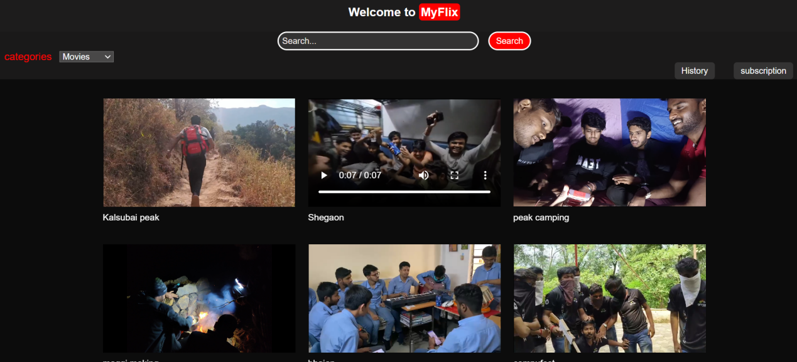

**Conclusion:**

In conclusion, "Crafting MyFlix" represents the culmination of efforts in designing a captivating user interface for a streaming platform using HTML, CSS, and JavaScript. While it currently serves as a front-end project, offering users a glimpse into the visual aesthetic and layout of the platform, it's important to note that further development is needed to integrate back-end functionalities for user authentication, subscription management, and content delivery. Moving forward, consideration should be given to expanding the project scope to include these essential features, transforming "Crafting MyFlix" from a static UI prototype into a fully functional streaming platform.